Fe-S Cluster Biogenesis in Plastids and Mitochondria in Plants

Fe-S clusters are essential inorganic cofactors of Fe-S proteins involved in vital biological processes such as electron transport, redox catalysis, sensing, signalling and gene regulation. Although structurally simple Fe-S cluster biogenesis requires an intricate interplay of numerous protein.
Fe-S cluster biogenesis can be divided into three steps: mobilization of S, Fe-S cluster assembly, and insertion into apoproteins. Most research on Fe-S assembly has come from bacteria and three systems exist termed NIF (nitrogen fixation), ISC (iron-sulfur cluster) and SUF (mobilisation of sulfur). The NIF system is involved in assembly and maturation of Fe-S clusters in nitrogenase proteins whilst ISC is more general found in bacteria and higher eukaryotes. The suf operon (sufABCDSE) is the third Fe-S system and Suf proteins are involved in Fe-S cluster biosynthesis and repair (Fig. 1).
In bacteria SufC interacts with SufB and SufD in the cytosol and it is thought that SufB/SufC/SufD forms an ATP-dependent “energizer” complex involved in Fe acquisition/transfer, and/or Fe-S cluster transfer to apoproteins. Further, SufE interacts with SufS involved in cysteine desulfuration whilst SufA acts as a transient scaffolding protein for the assembled Fe-S cluster. Fe-S clusters are finally transferred onto apoproteins to generate functional Fe-S proteins.
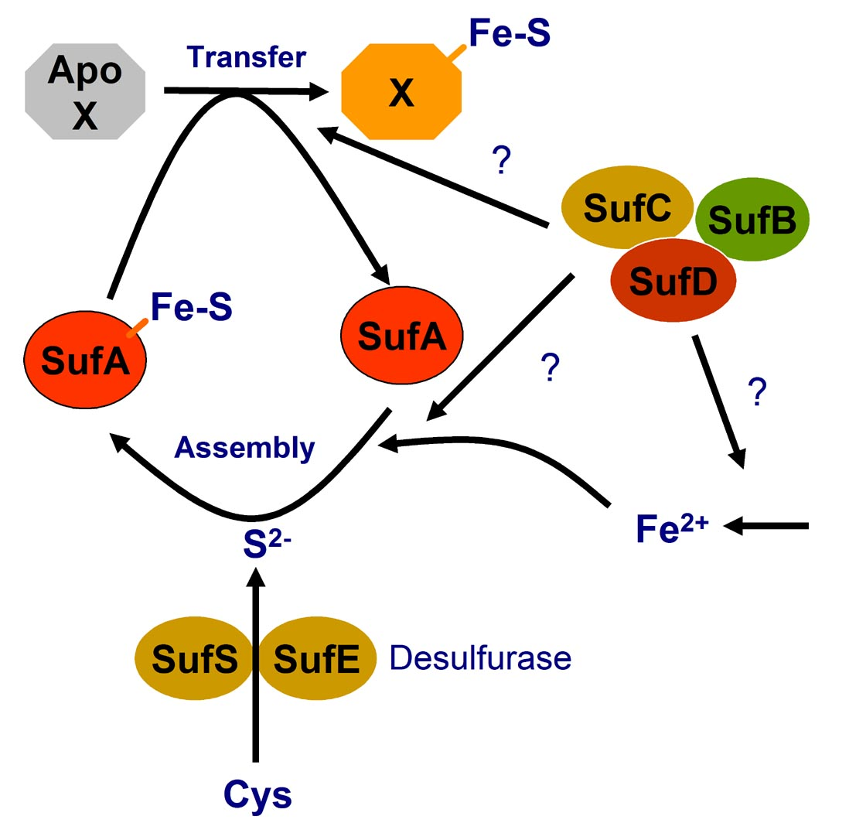
Fig 1. A schematic diagram showing the role of the different Suf proteins in bacteria. SufB/SufC/SufD form an energizer complex, SufE/SufS acts as a desulphurization complex whilst SufA acts as a scaffold protein for Fe-S clusters.

Despite excellent insight into Fe-S cluster biogenesis in bacteria and yeast, Fe-S cluster biogenesis and repair represent poorly understood processes in plants. Our research is focused on understanding the molecular and cellular mechanisms of Fe-S cluster biogenesis in both plastids and mitochondria in plants and to dissect how seemingly two separate biosynthetic pathways are coordinated between two different organelles.

AtSufC/AtNAP7
Initial insight into the function of the Arabidopsis SUF system came from our characterization of the Arabidopsis SufC homolog AtNAP7. AtNAP7 is a plastid-localized ABC/ATPase that can complement SufC-deficiency in E. coli under oxidative stress (Fig. 2). Loss of AtNAP7 leads to embryo lethality and mutant embryonic plastids are abnormal with altered thylakoid structures. This argues that SUF- mediated Fe-S cluster biogenesis and/or repair in Arabidopsis plastids is essential for plant development. AtNAP7 also interacts with the plastid-localized SufD homolog AtNAP6.

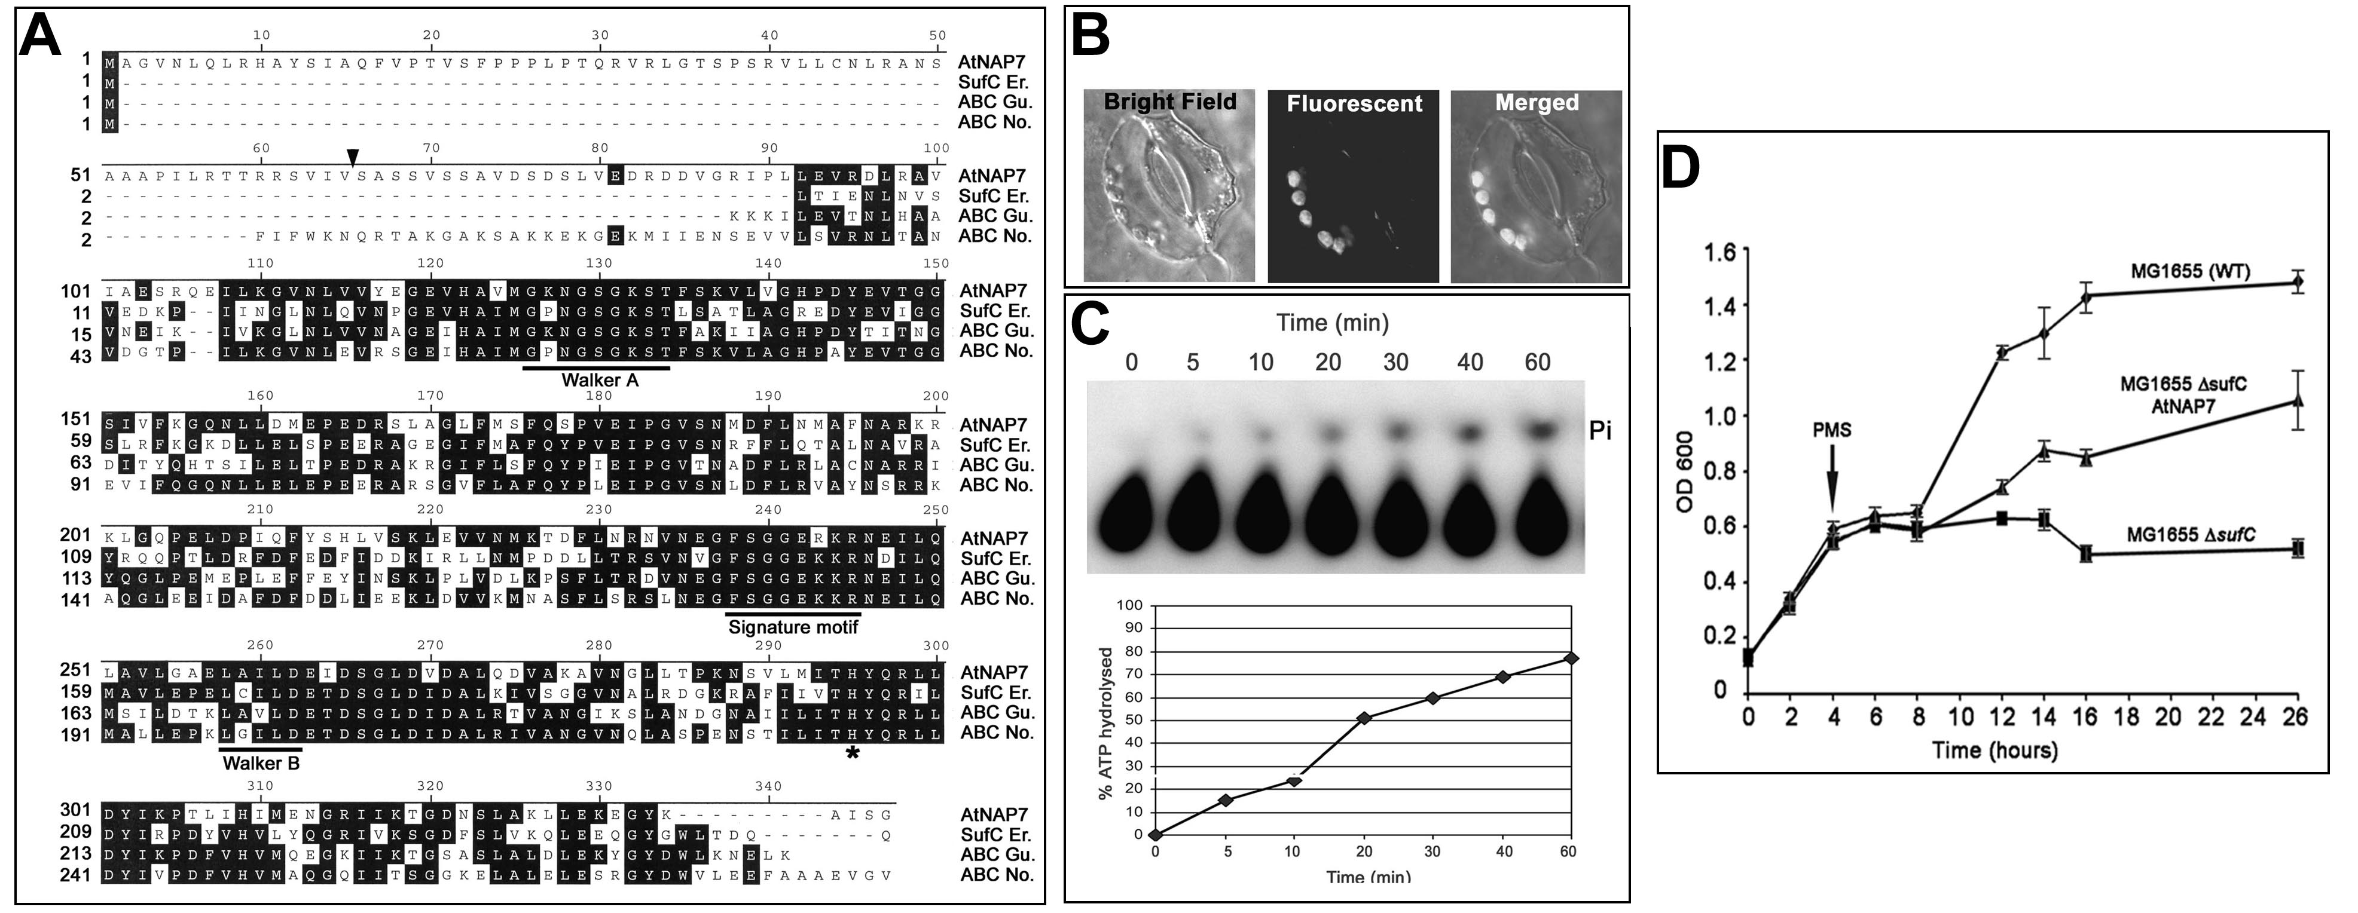

Fig 2. (A) Comparison of AtNAP7 with Erwinia SufC, G. theta sulfate ABC protein, and N. punctiforme ABC protein. (B) Localization of AtNAP7/YFP in tobacco stomata. (C) TLC showing that AtNAP7 is an ATPase. (D) AtNAP7 can complement SufC deficiency in E. coli. PMS was added to WT E. coli (MG1655), an E. coli SufC mutant (MG1655ΔSufC) and E. coli MG1655ΔSufC expressing AtNAP7 (MG1655ΔSufC AtNAP7).

AtSufB/AtNAP1
Based on our identification of AtNAP7 we speculated that a SufB-like protein exists in plastids. We demonstrated that the Arabidopsis plastid-localized SufB homolog AtNAP1 complements SufB deficiency in E. coli during oxidative stress (Fig. 3A). However, in contrast to prokaryotic SufB proteins AtNAP1 is a Fe-stimulated ATPase (Fig. 3B) which can homodimerize and interact with AtNAP7 in chloroplasts (Fig. 3C) suggesting the presence of a SufB/SufC/SufD complex.

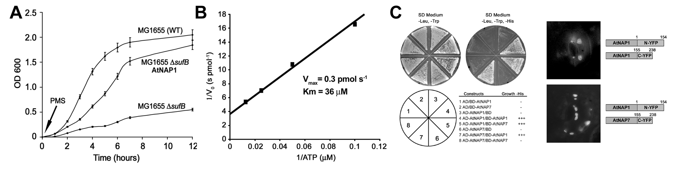

Fig. 3. (A) AtSufB/AtNAP1 can complement SufB deficiency in E. coli. (B) AtSufB/AtNAP1 is an ATPase. (C) AtSufB/AtNAP1 forms homodimers and interacts with AtSufC/AtNAP7 in yeast and in living chloroplast using BiMolecular Fluorescence Complementation (BiFC).

AtSufE
To investigate sulfur acquisition as part of Fe-S cluster biogenesis we identified AtSufE from Arabidopsis. We showed that AtSufE can rescue growth defects in SufE-deficient E. coli (Fig. 4A) but in contrast to other SUF proteins AtSufE localises to plastids and mitochondria (Fig. 4B) interacting with the plastidic AtSufS and mitochondrial AtNifS1 cysteine desulfurases (Fig. 4C). AtSufE activates AtSufS and AtNifS1 (Fig. 4D) and AtSufE activity restoration in either plastids or mitochondria is not sufficient to rescue embryo lethality in AtSufE loss-of-function mutants. AtSufE overexpression leads to elevated cysteine desulphurization activity, chlorosis and retarded development. These findings demonstrate that plastidic and mitochondrial Fe-S cluster biogenesis share a common, essential component that activates plastidic and mitochondrial desulphurases.

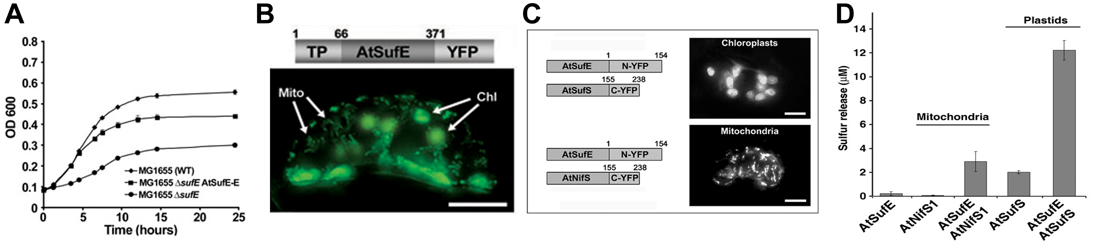
Fig. 4. (A) AtSufE can complement SufE deficiency in E. coli. (B) AtSufE localizes to both plastids and mitochondria. (C) AtSufE interacts with AtSufS in plastids and AtNifS in mitochondria using BiFC which results in (D) desulfurases activation in both organelles.

To fully understand Fe-S cluster biogenesis and repair in Arabidopsis plastids and mitochondria and its role during plant development, we are functionally characterizing central Suf proteins in terms of biochemical properties, protein-protein interactions and phenotypic consequences of gain-of function and loss-of-function mutants. Furthermore, we are characterizing other Fe-S cluster biogenesis systems including the ISC system.

Recent publications
Xiang Ming Xu and Simon Geir Møller (2007) Iron-sulfur cluster biogenesis and repair in Arabidopsis thaliana. EMBO Rep. Invited review
Xiang Ming Xu and Simon Geir Møller (2006) AtSufE is an essential activator of plastidic and mitochondrial desulfurases in Arabidopsis. EMBO J. 25. 900-909.
Xiang Ming Xu, Sally Adams, Nam-Hai Chua and Simon Geir Møller (2005) AtNAP1 represents an atypical SufB protein in Arabidopsis plastids. J. Biol. Chem. 280, 6648-6654.
Xiang Ming Xu and Simon Geir Møller (2004) AtNAP7 is a plastidic SufC-like ABC/ATPase essential for Arabidopsis embryogenesis. Proc.Natl.Acad.Sci.U.S.A. 101, 9143-9148.

