2013 International Conference on Cloud Computing and Big Data
FUZHOU LAKESIDE HOTEL
FuZhou, China
December 16-19, 2013
Call for Papers
“Cloud” is a common metaphor for an Internet accessible infrastructure (e.g. data storage and computing hardware) which is hidden from users. Cloud Computing makes data truly mobile and a user can simply access a chosen cloud with any internet accessible device. In Cloud Computing, IT-related capabilities are provided as services, accessible without requiring detailed knowledge of the underlying technology. Thus, many mature technologies are used as components in Cloud Computing, but still there are many unresolved and open problems. The Cloud Computing Association (www.cloudcom.org) aims to bring together researchers who work on cloud computing and related technologies. CloudCom-Asia (asia2013.cloudcom.org) aims to bring together researchers who work on cloud computing and related technologies.

- Sponsors
Fuzhou University
University of Stavanger
Fujian Normal University
Nanjing University of Post & Telcom
Chung Hua University
IEEE Computer Society
Cloud Computing Association
IEEE Cloud Computing Initiative
TSCGCC, IEEE Communications Society
IEEE Cloud Computing Initiative
Fuzhou City Government
- Important Dates
Submission: Sept. 17, 2013
Notification: Oct. 11, 2013
Camera-ready: Oct. 25, 2013
Author registration: Oct. 25, 2013
Workshop Proposals: June. 30, 2013
- Keynote Speakers
Academia:

Prof. Chunming Rong,
University of Stavanger (UiS)
Norway

Dr. Rajkumar Buyya
University of Melbourne
Australia

Dr. Jie Li
University of Tsukuba
Japan

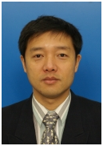
Prof. Hai Jin
Huazhong University of Science and Technology(HUST)
China
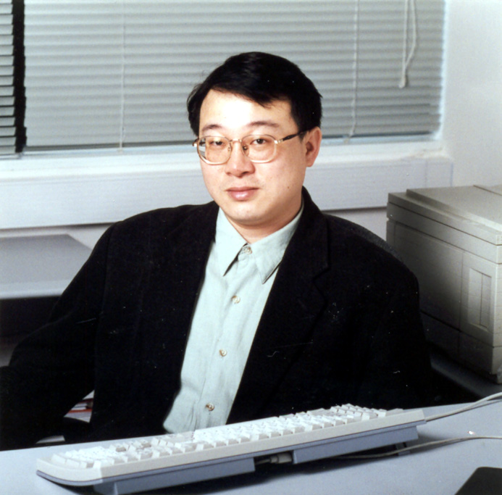
Dr. Cho‐Li Wang
University of Hong Kong
China
Industrial:

Dr. Wu Chou
(Global Head of Huawei IT Lab
& Vice President & Chief IT Scientist, China)

- Special Issues
Best Paper Awards will be presented to high quality papers.
Selected papers, after further extensions and revisions, will be published
in special issues of the following prestigious journals
Journal of Internet Technology (ISI Impact Factor = 0.448)
International Journal of Cloud Computing (Scopus, EI)
- Submission & Publication
Manuscripts need to be prepared according to the IEEE CS format (Format Link)
For regular papers, the page should be 6-8 pages.
For short papers, the page should be 4-6 pages.
For workshops, the page should be 6 pages.
For poster and demo, the page limit will be 4 pages.

- Topics
Architecture
*Cloud Infrastructure as a Service
*Cloud Platform as a Service
*Cloud federation and hybrid cloud infrastructure
*Programming models and systems/tools
*Green data center
*Networking technologies for data center
*Cloud system design with FPGA, GPU, APU
*Monitoring, management and maintenance
*Economic and business models
*Dynamic resource provisioning
MapReduce
*Performance characterization and optimization
*MapReduce on multi-core, GPU
*MapReduce on hybrid distributed environments
*MapReduce on opportunistic/heterogeneous computing systems
*Extension of the MapReduce programming model
*Debugging and simulation of MapReduce systems
*Data-intensive applications using MapReduce
*Optimized storage for MapReduce applications
*Fault-tolerance & Self-* capabilities
Security and Privacy
*Accountability
*Audit in clouds
*Authentication and authorization
*Cryptographic primitives
*Reliability and availability
*Trust and credential management
*Usability and security
*Security and privacy in clouds
*Legacy systems migration
*Cloud Integrity and Binding Issues
Services and Applications
*Cloud Service Composition
*Query and discovery models for cloud services
*Trust and Security in cloud services
*Change management in cloud services
*Organization models of cloud services
*Innovative cloud applications and experiences
*Business process and workflow management
*Service-Oriented Architecture in clouds
Virtualization
*Server, storage, network virtualization
*Resource monitoring
*Virtual desktop
*Resilience, fault tolerance
*Modeling and performance evaluation
*Security aspects
*Enabling disaster recovery, job migration
*Energy efficient issues

HPC on Cloud
*Load balancing for HPC clouds
*Middleware framework for HPC clouds
*Scalable scheduling for HPC clouds
*HPC as a Service
*Performance Modeling and Management
*Programming models for HPC clouds
*HPC cloud applications
*Optimal cloud deployment for HPC
Big Data:
*Machine learning
*Data mining
*Approximate and scalable statistical methods
*Graph algorithms
*Querying and search
*Data Lifecycle Management for Big Data (sources, cleansing, federation, preservation, privacy, etc.)
*Frameworks, tools and their composition
*Storage and analytic architectures
*Performance and debugging
*Hardware optimizations for Big Data (multi-core, GPU, networking, etc.)
*Data Flow management and scheduling

All accepted papers will be published by IEEE CPS (EI).



